Hello, how are you?
Hello, hello, hello, how are you?
Hello, hello, hello, how are you?
I’m good.
I’m great!
I’m wonderful!
I’m good.
I’m great!
I’m wonderful!
Hello, hello, hello, how are you?
Hello, hello, hello, how are you?
I’m tired.
I’m hungry.
I’m not so good.
I’m tired.
I’m hungry.
I’m not so good
https://www.youtube.com/watch?v=tVlcKp3bWH8

What’s the weather?
What’s the weather? What’s the weather?
What’s the weather like today?
Tell us (child’s name) What’s the weather?
What’s the weather like today?
Is it sunny? (hold hands above head in a circle)
Is it cloudy? (cover eyes with hands)
Is it rainy out today? (flutter fingers downward)
Is it snowy? (wrap arms around the body and shiver)
Is it windy? (“blow children over with a swoop of your arms)
What’s the weather like today?
https://www.youtube.com/watch?v=hQCt_tDh3s4
(od 1:22)

Days of the week
Monday
Tuesday
Wednesday
Thursday
Friday
Saturday
Sunday
https://www.youtube.com/watch?v=36n93jvjkDs

JĘZYK ANGIELSKI
gr. MOTYLKI/ŻABKI

Tooty Ta
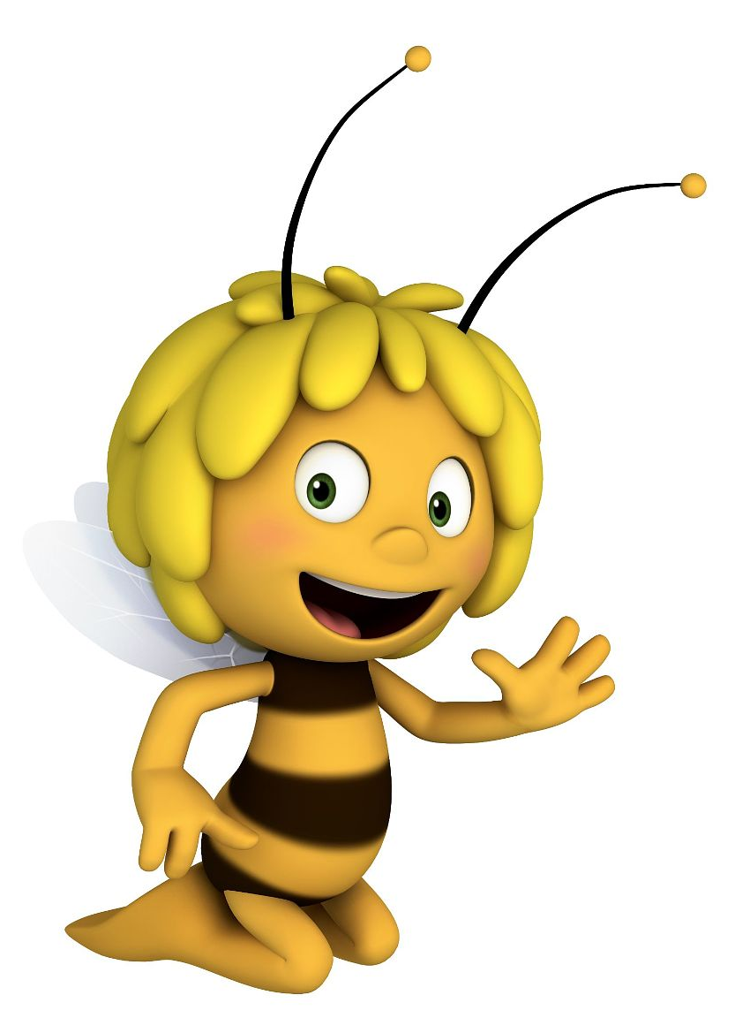
CHORUS: A tooty-ta, a tooty-ta, a tooty ta-ta!
A tooty-ta, a tooty-ta, a tooty ta-ta!
Thumbs up CHORUS
Thumbs up, Elbows back CHORUS
Thumbs up, Elbows back, Knees together CHORUS
Thumbs up, Elbows back, Knees together, Feet apart CHORUS
Thumbs up, Elbows back, Knees together, Feet apart, Bottoms up CHORUS
Thumbs up, Elbows back, Knees together, Feet apart, Bottoms up, Head back CHORUS
Thumbs up, Elbows back, Knees together, Feet apart, Bottoms up, Head back, Tongue out, CHORUS
https://www.youtube.com/watch?v=ea4TVg0_8Dk

Wind the Bobbin up
Wind the bobbin up. Wind the bobbin up.
Pull, pull, clap, clap, clap.
Wind it back again. Wind it back again.
Pull, pull, clap, clap, clap.
Point to the ceiling. Point to the floor.
Point to the window. Point to the door.
Clap your hands together, 1, 2, 3.
Put your hands upon your knee.
Wind the bobbin up. Wind the bobbin up.
Pull, pull, clap, clap, clap.
Wind it back again. Wind it back again.
Pull, pull, clap, clap, clap.
Point to the ceiling. Point to the floor.
Point to the window. Point to the door.
Clap your hands together, 1, 2, 3.
Put your hands upon your knee.
https://www.youtube.com/watch?v=pDuaaEq7rk4

